Jackson County Fire District 4

Monthly Report: September 2023

Total Number of Incidents for September 2023 79

Average Response time
Dispatched and cancelled enroute calls have been excluded

 | Average Response Time | # of Calls
City limits | 5:15 | 47
Non City/Rural | 10:50 | 27

Monthly Call Volume

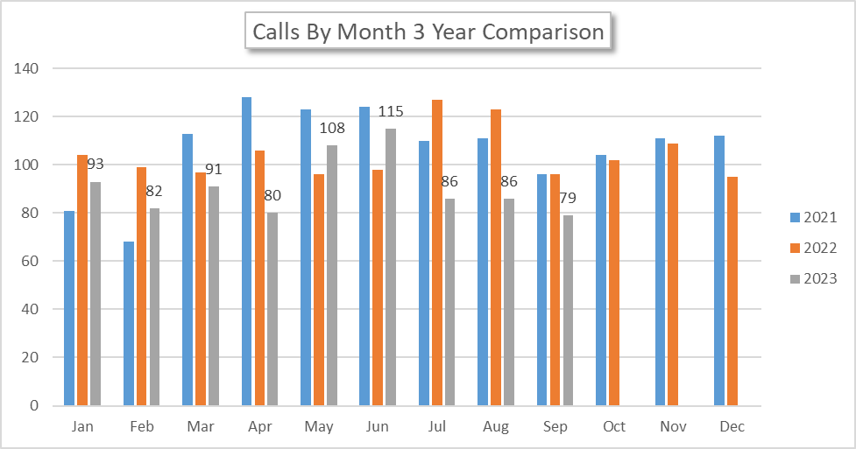
Breakdown by Major Incident Type

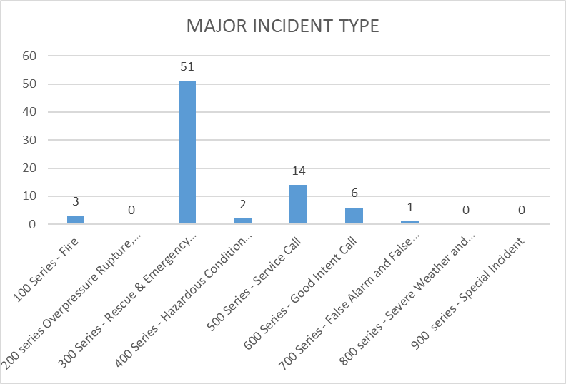

MAJOR INCIDENT TYPE | # INCIDENTS | % of TOTAL
100 Series - Fire | 3 | 3.90%
200 series Overpressure Rupture, Explosion, Overheat No Fire | 0 | 0.00%
300 Series - Rescue & Emergency Medical Service | 51 | 66.23%
400 Series - Hazardous Condition (No Fire) | 2 | 2.60%
500 Series - Service Call | 14 | 18.18%
600 Series - Good Intent Call | 6 | 7.79%
700 Series - False Alarm and False Call | 1 | 1.30%
800 series - Severe Weather and Natural Disaster | 0 | 0.00%
900 series - Special Incident | 0 | 0.00%
TOTAL | 77 | 100%

Call History

