Jackson County Fire District 4

Monthly Report: July 2023

Total Number of Incidents for July 2023 86

Average Response time
Dispatched and cancelled enroute calls have been excluded

 | Average Response Time | # of Calls
City limits | 6:39 | 49
Non City/Rural | 10:33 | 26

Monthly Call Volume

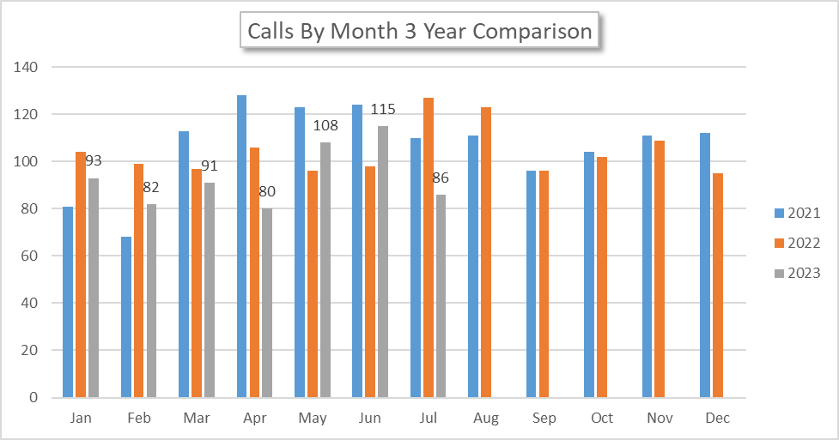
Breakdown by Major Incident Type

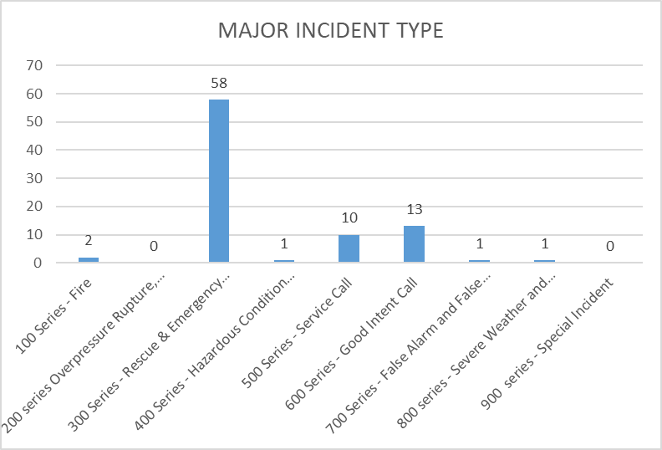

MAJOR INCIDENT TYPE | # INCIDENTS | % of TOTAL
100 Series - Fire | 2 | 2.33%
200 series Overpressure Rupture, Explosion, Overheat No Fire | 0 | 0.00%
300 Series - Rescue & Emergency Medical Service | 58 | 67.44%
400 Series - Hazardous Condition (No Fire) | 1 | 1.16%
500 Series - Service Call | 10 | 11.63%
600 Series - Good Intent Call | 13 | 15.12%
700 Series - False Alarm and False Call | 1 | 1.16%
800 series - Severe Weather and Natural Disaster | 1 | 1.16%
900 series - Special Incident | 0 | 0.00%
TOTAL | 86 | 100%

Call History

